# Data Set:

We take our data set from [kaggle](https://www.kaggle.com/doyonghoon/baby-data). Our real data set have those Colum’s

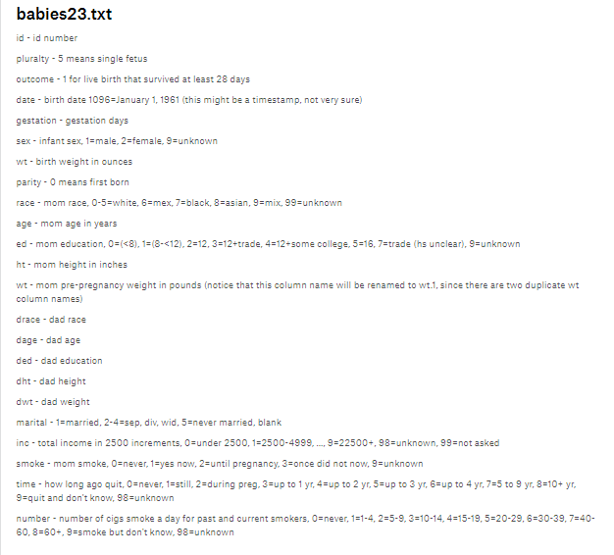

We remove [**'pluralty'**,**'date'**,**'outcome'**,**'id'**,**'sex'**,**'marital']**

This Colum from real data set.

Linear Regression data set: